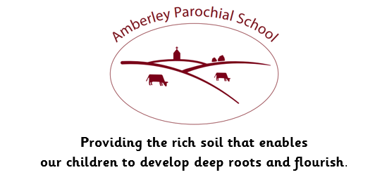

Dear parents and carers,
Welcome back!
I would like to start by wishing you all a Happy New Year! I hope that you all had a good Christmas and, would like to wish you all the best for 2024.
I am excited to start the spring term and have many new challenges for developing the children’s learning. I will be continuing to keep you up to date on these using the class blog on our school webpage and through Tapestry. I would be grateful if you could take the time to look at and comment on the entries we place on Tapestry, as it is helpful to receive your feedback and it can be a nice way for you to share learning and find out what your children have been doing. You are very welcome to add your own observations, photos or notes too.
This term we will be completing our Phase 3 phonics learning, which focuses on digraphs, two or three letters making one sound and then progressing to Phase 4 after the half term break. In Literacy, Language and Communication we will be looking at traditional tales with a focus on The Gingerbread Man. I will be digging deeper into the vocabulary of storytelling to encourage the children to write their own simple sentences to retell a familiar story. We will also be looking at other genres of writing including instructions, letters and recounts.
In Maths, we will continue exploring the numbers to 10 looking at composition of each number, one more, one less, counting on and counting back. We will be adding, subtracting and sharing as well as beginning our Club Maths challenges where the children will have an opportunity to practise rapid recall of number bonds. We will also revisit mass and capacity, length and height as well as looking in more detail at 3D shapes.
In our work on Understanding of the World and Expressive Arts and Design, we will be looking at traditions and festivals such as Easter and the Lunar New Year. We will be talking about seasonal changes and making observations in our local environment. We will talk about growth, animal and plant lifecycles and life on farms around the world including a look at past and present ways of life.
I am in the process of organising a trip or two to support the learning we are doing in the classroom and I will keep you posted on these nearer the time.
So, lots to look forward to and now just a few reminders:
Water bottles and snacks
Children will need a named water bottle in the classroom at all times, and they will be encouraged to drink regularly. Until they are 5 years old, children are entitled to free milk each day, through the Cool Milk scheme. Once they are 5 years old, milk can be ordered through the Cool milk link on the school website (https://www.amberleyschool.co.uk/dexters). Children are provided with a fresh fruit snack each day, though are welcome to bring their own if they would prefer. Please ensure that snacks are in the form of fresh fruit or vegetables, in order to help us promote healthy balanced diets.

Lunches
I would be really grateful if you could look at the menu with your child each day so that they know what they are going to order, or whether they would prefer a packed lunch. There have been a few times when children have not wanted what is on offer and have not eaten well. This is upsetting for them and can limit their readiness to engage in their learning during the afternoon.

PE kits and protective clothing
Children can come to school in their PE kits on Fridays. Replacement shorts, t-shirts and hoodies can be bought through the school office and we also have a selection of pre-loved items available if your child has had a growth spurt over the festive period! Children will also need a pair of plain tracksuit bottoms or leggings for colder weather and suitable footwear (Please could you check that these still fit!)
Children will need to have their waterproofs in school ready for messy play and walks as usual and also gloves, hats and scarves as the weather is set to remain chilly. All items of uniform must be clearly named please. I am increasingly trying to locate items which have gone astray and this can be time consuming so if the label can be read by the child as well as the adults this would be a really big help. Please check that any handwritten labels have not disappeared in the wash!
Reading books and word sheets
We will continue to update and send home reading books and sound sheets. This term, we will be introducing more digraphs (two letters making one sound) and we would be grateful if you could find time to sit with your child to revise these sounds each day, in order to develop familiarity and recognition. We will continue to send books on Mondays and Thursdays and will listen to each child read to ensure that they are reading with fluency before we change their books. Children need to bring their reading books into school every day, along with their reading record.
School website and Dexter Class Blog
If you have not yet signed up to the school website, I would really encourage you to do so. You can benefit from our weekly class blog, where we detail areas of learning for the week. You are also able to email me directly using the class page contact box.
https://www.amberleyschool.co.uk/dexters
Thank you for your continued support. I look forward to seeing you all over the next few weeks.
Kind regards,

Mrs S Penn

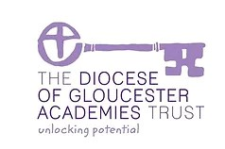
Amberley Parochial School,
Amberley, Stroud, Gloucestershire GL5 5JG
Head teacher: Mrs A Flight
t: 01453 873349
e: admin@amberley.gloucs.sch.uk
www.amberleyschool.co.uk

